DATA ANALYTICS INTERNSHIP PROGRAM

STUDENT MANAGEMENT &
PERFORMANCE ANALYTICS SYSTEM

AN INTERNSHIP PROJECT REPORT
Submitted by
SELVAPRIYA G

(Reg No:110725102224)

in partial fulfillment for the award of the degree of

BACHELOR OF TECHNOLOGY IN

Artificial Intelligence & Data Science



J.N.N Institute of Engineering
(An Autonomous Institute , Affiliated to Anna University, Chennai)

AUGUST – 2026



VISION OF THE INSTITUTE:
Lead the transformation of engineering and management learning experience to educate the next generation of innovators and entrepreneurs who want to make the world a better place.

MISSION OF THE INSTITUTE:

IM1: To develop the required resources and infrastructure and to establish a conducive ambience for the teaching-learning process.

IM2: To nurture professional and ethical values in the students and to instils in them a spirit of innovation and entrepreneurship.

IM3: To encourage a desire for higher learning and research in the students and to equip them to face global challenges.

IM4: To provide opportunities for students to learn job-relevant skills to make them industry ready.

IM5: To interact with industries and other organization to facilitate transfer of knowledge and know-how.



VISION OF THE DEPARTMENT:
To impart quality-education, inculcate professionalism and enhance the problem-solving skills of the students in the domain of Artificial Intelligence & Data Science by applying recent technological tools and incorporating collaborative principles with a focus to make them industry ready.

MISSION OF THE DEPARTMENT:

- DM 1: To enhance the knowledge of the students with most recent
advancements and refresh their insights in the field of Artificial Intelligence and Data Science.
- DM 2: To equip the students with strong fundamental concepts,
analytical capability, programming and problem-solving skills.
- DM 3: To make the students industry ready and to enhance their employability through training, internships and real-time projects.
- DM 4: To guide the students to perform research on Artificial Intelligence and Data Science, with the aim to provide solutions to the problems of the industry

PROGRAM OUTCOMES

S.NO | GRADUATE ATTRIBUTE | PROGRAM OUTCOMES
PO1 | Engineering knowledge | Apply the knowledge of mathematics, science, engineering fundamentals, and an engineering specialization to the solution of complex engineering  problems.
PO2 | Problem analysis | Identify, formulate, review research literature, and analyze complex engineering problems reaching substantiated conclusions using first principles of mathematics,  natural sciences, and engineering sciences.
PO3 | Design/Development of solutions | Design solutions for complex engineering problems  and design system components or processes that meet the specified needs with appropriate consideration for the public health and safety, and the cultural, societal, and environmental considerations.
PO4 | Conduct investigations of complex problems | Use research-based knowledge and research methods including design of experiments, analysis and interpretation of data, and synthesis of the information to provide valid conclusions.
PO5 | Modern Tool usage | Create, select, and apply appropriate techniques, resources, and modern engineering and IT tools including prediction and modeling to complex engineering activities with an understanding of the limitations.
PO6 | The Engineer and society | Apply reasoning informed by the contextual knowledge to assess societal, health, safety, legal and cultural issues and the consequent responsibilities relevant to the professional engineering practice
PO7 | Environment and sustainability | Understand the impact of the professional engineering solutions in societal and environmental contexts, and demonstrate the knowledge of, and need for sustainable development.

PO8 | Ethics | Apply ethical principles and commit to professional ethics and responsibilities and norms of the engineering practice.
PO9 | Individual and team work | Function effectively as an individual, and as a member or leader in diverse teams, and in multidisciplinary settings.
PO10 | Communication | Communicate effectively on complex engineering activities with the engineering community and with society at large, such as, being able to comprehend and write effective reports and design documentation, make effective presentations, and give and receive clear instructions.
PO11 | Project management and finance | Demonstrate knowledge and understanding of the engineering and management principles and apply these to one’s own work, as a member and leader in a team, to manage projects and in multidisciplinary environments.
PO12 | Life-long learning | Recognize the need for, and have the preparation and ability to engage in independent and life-long learning in the broadest context of technological change.

PROGRAM EDUCATIONAL OBJECTIVES (PEO)

S.No | PROGRAM EDUCATIONAL OBJECTIVES (PEO)
PEO1 | To provide graduates with the proficiency to utilize the fundamental knowledge of basic sciences, mathematics, Artificial Intelligence, data science and statistics to build systems that require management and analysis of large volume of data.
PEO2 | To enrich graduates with necessary technical skills to pursue pioneering research in the  field of AI and Data Science and create disruptive and sustainable solutions for the welfare of ecosystems.
PEO3 | To enable graduates to think logically, pursue lifelong learning and collaborate with an ethical attitude in a multidisciplinary team

m

PROGRAM SPECIFIC OBJECTIVES (PSOs)

S.No | PROGRAM SPECIFIC OBJECTIVES (PSOs)
PSO1 | Graduates should be able to evolve AI based efficient domain specific processes for effective decision making in several domains such as business and governance domains.
PSO2 | Graduates should be able to arrive at actionable Fore sight, Insight , hind sight from data for solving business and engineering problems
PSO3 | Graduates should be able to create, select and apply the theoretical knowledge of AI and Data Analytics along with practical industrial tools and techniques to manage and solve wicked societal problems.



BONAFIDE CERTIFICATE

Certified that this internship project report
“STUDENT MANAGEMENT & PERFORMANCE ANALYTICS SYSTEM”
(Data Analytics Internship) is the bonafide work of “SELVAPRIYA G”
(Reg No: 110725102224) who carried out the project under my supervision.

Signature of the HOD with date
Signature of the Supervisor with date

Dr. P. Nagarajan Miss. Brindha . S

Professor and Head,
Department of Artificial Intelligence & Data Science Engineering,

J.N.N Institute of Engineering, Chennai
Project Supervisor,
Department of Artificial Intelligence & Data Science Engineering,

J.N.N Institute of Engineering,
Chennai

Certified that the above students have attend of viva voce during the exam
held on……………….

INTERNAL EXAMINER EXTERNAL EXAMINER

ACKNOWLEDGEMENT

First and foremost, we express our sincere gratitude to our Beloved FOUNDER & CHAIRMAN Shri. S. JAYACHANDRAN B.Sc., B.L., and also heartfelt thanks to our VICE CHAIRMAN Mr. NAVEEN JAYAHANDRAN M.S., for providing necessary facilities for the completion of our project.
We thank our PRINCIPAL Dr. G. MOHANBABU, Ph.D., for the encouragement provided with the congenial environment essential for us to complete the project.
We take this opportunity to express our gratitude to our HEAD OF THE DEPARTMENT Dr. P. NAGARAJAN and all other faculty members in the Department of ARTIFICIAL INTELLIGENCE AND DATA SCIENCE for giving us continuous encouragement for completing our project.
We extend our sincere thanks to VEI Technologies Pvt. Ltd., Chennai and its Founder & CEO, Dr. B. Ezhilavan, for giving us the opportunity to undergo this Data Analytics internship, and we sincerely thank our project supervisor and the entire Data Analytics team at VEI Technologies for their guidance, patience and technical support throughout this internship.
Finally, we would like to thank our parents and friends for their constant support and encouragement.

ABSTRACT

Data is now central to every decision taken in education, business and industry, and data analytics is the discipline that turns raw data into useful knowledge. This report documents the work carried out during the Data Analytics Internship at VEI Technologies Pvt. Ltd., Chennai, completed between 3rd August 2026 and 20th August 2026 under the guidance of the project supervisor.

The internship project, titled “Student Management & Performance Analytics System”, was built in five connected modules. Module 1 collected the raw student, marks and subject data. Module 2 cleaned the data with Python and pandas by removing duplicate records, standardising department names and filling missing values. Module 3 designed a normalised SQLite database and added student management operations – add, search, update and delete. Module 4 analysed the results using SQL and statistics to calculate totals, averages, grades, ranks and arrears. Module 5 presented the findings through charts, a correlation study, an at-risk student list, an analytics dashboard and an Excel report.

The analysis of 120 students showed a class average of 71.73 marks, a pass percentage of 83.3 % and a positive correlation (r = 0.673) between attendance and marks. 33 students were identified as at-risk. Together, the project demonstrates the complete data analytics life cycle – collection, cleaning, storage, analysis, visualization and reporting – and shows how such a system can help a department monitor performance and support weaker students in time.

TABLE OF CONTENTS
CHAPTER NO | TITLE | PAGE NO.
1 | INTRODUCTION | 1
 | 1.1 OVERVIEW | 1
 | 1.2 INTERNSHIP DETAILS | 1
 | 1.3 OBJECTIVES | 1
 | 1.4 OVERVIEW OF THE PROJECT MODULES | 2
 | 1.5 PROBLEM STATEMENT | 2
 | 1.6 SCOPE OF THE PROJECT | 3
 | 1.7 ORGANISATION OF THE REPORT | 3
2 | LITERATURE REVIEW | 4
 | 2.1 DATA ANALYTICS AND DATA CLEANING | 4
 | 2.2 RELATIONAL DATABASES AND SQL | 4
 | 2.3 DATA VISUALIZATION AND DASHBOARDS | 4
 | 2.4 ACADEMIC PERFORMANCE ANALYTICS | 4
 | 2.5 TOOLS AND THEIR PURPOSE | 5
 | 2.6 EXISTING APPROACHES AND THEIR LIMITATIONS | 5
 | 2.7 NEED FOR THE PROPOSED SYSTEM | 5
 | 2.8 STATISTICAL MEASURES USED | 6
3 | METHODOLOGY | 7
 | 3.1 OVERALL APPROACH | 7
 | 3.2 DATA SET DESCRIPTION | 7
 | 3.3 DATABASE DESIGN | 7
 | 3.4 EVALUATION AND GRADING SCHEME | 8
 | 3.5 ANALYSIS METHODS | 8
 | 3.6 SYSTEM REQUIREMENTS | 9
 | 3.7 FUNCTIONAL AND NON-FUNCTIONAL REQUIREMENTS | 9
 | 3.8 DATA PROCESSING WORKFLOW | 10
4 | IMPLEMENTATION | 11
 | 4.1 MODULE 1: PROJECT SETUP AND DATA COLLECTION | 11
 | 4.2 MODULE 2: DATA CLEANING | 11
 | 4.3 MODULE 3: DATABASE AND STUDENT MANAGEMENT | 13
 | 4.4 MODULE 4: PERFORMANCE ANALYSIS | 14
 | 4.5 MODULE 5: VISUALIZATION AND REPORTING | 15
 | 4.6 SQL QUERIES USED FOR ANALYSIS | 19
 | 4.7 GRADE AND RISK LOGIC | 20
 | 4.8 TESTING OF THE SYSTEM | 20
 | 4.9 CHALLENGES FACED AND SOLUTIONS | 21
5 | RESULTS AND DISCUSSION | 22
 | 5.1 DATA CLEANING RESULTS | 22
 | 5.2 OVERALL PERFORMANCE | 22
 | 5.3 SUBJECT-WISE ANALYSIS | 22
 | 5.4 DEPARTMENT-WISE ANALYSIS | 23
 | 5.5 ATTENDANCE AND PERFORMANCE | 23
 | 5.6 AT-RISK STUDENTS | 23
 | 5.7 KEY FINDINGS AND RECOMMENDATIONS | 23
 | 5.8 GRAPHICAL SUMMARY OF THE RESULTS | 24
 | 5.9 COMPARISON WITH THE MANUAL METHOD | 24
 | 5.10 DISCUSSION | 25
6 | CONCLUSION AND FUTURE WORK | 26
 | 6.1 CONCLUSION OF INDIVIDUAL MODULES | 26
 | 6.2 OVERALL CONCLUSION | 26
 | 6.3 FUTURE WORK | 26
 | 6.4 SKILLS ACQUIRED | 26
 | 6.5 LIMITATIONS OF THE PRESENT WORK | 27
 | 6.6 BENEFITS OF THE SYSTEM | 27
 | REFERENCES | 28
 | APPENDIX – INTERNSHIP CERTIFICATE | 29

CHAPTER 1
INTRODUCTION

1.1 Overview
Educational institutions generate a large volume of data every semester – student profiles, attendance registers, internal assessment marks and university examination results. In most colleges this data is still stored in separate spreadsheets and paper registers, which makes it slow to search, easy to duplicate and difficult to analyse. As a result, weak students are usually identified only after the results are published, when it is already too late to help them.
This report presents the Student Management & Performance Analytics System, developed during the Data Analytics Internship at VEI Technologies Pvt. Ltd., Chennai, from 3rd August 2026 to 20th August 2026. The project collects raw student data, cleans it with Python, stores it in a structured relational database, analyses academic performance using SQL and statistical methods, and finally presents the findings through charts, a dashboard and an Excel report.
The system therefore covers the complete data analytics life cycle – data collection, data cleaning, storage, analysis, visualization and reporting – on a realistic student data set, and it gives the department a simple way to monitor attendance and results and to identify students who need academic support.

1.2 Internship Details
Table 1.1 – Details of the internship
Particulars | Details
Name of the Intern | SELVAPRIYA G
Register Number | 110725102224
Department | Artificial Intelligence & Data Science
Institution | J.N.N Institute of Engineering, Chennai
Organization | VEI Technologies Pvt. Ltd., Chennai – 600 048
Role | Data Analytics Intern (IT Department)
Duration | 15 days (03.08.2026 to 20.08.2026)
Project Title | Student Management & Performance Analytics System
Certificate No. | VEI0820261564

The internship was offered through an internship offer letter dated 1st August 2026. Its purpose was to provide practical industry exposure and hands-on experience in data analytics, and the intern reported directly to the designated project supervisor throughout the programme.

1.3 Objectives
    - To collect and organise student profile, attendance and marks data in a structured form.
    - To clean raw data by removing duplicates, fixing inconsistent labels and handling missing values using Python and pandas.
    - To design a normalised relational database (SQLite) and provide basic student management operations – add, search, update and delete.
    - To analyse academic performance using SQL queries and statistics – averages, pass percentage, grades, ranks and correlation.
    - To visualise the results with charts and an analytics dashboard that supports quick decisions.
    - To identify at-risk students automatically, using attendance and arrear criteria, and to export the results as a report.

1.4 Overview of the Project Modules
The project was divided into five connected modules, each building on the output of the previous one:
    - Module 1 – Data Collection & Setup: project structure, raw data files (students, marks, subjects) and initial data exploration.
    - Module 2 – Data Cleaning: duplicate removal, label standardisation and missing-value treatment using pandas.
    - Module 3 – Database & Student Management: SQLite database design, table relationships, SQL queries and CRUD operations.
    - Module 4 – Performance Analysis: total, average, grade, rank and arrear calculation, subject-wise and department-wise statistics.
    - Module 5 – Visualization & Reporting: charts, correlation study, at-risk student identification, dashboard and Excel report.
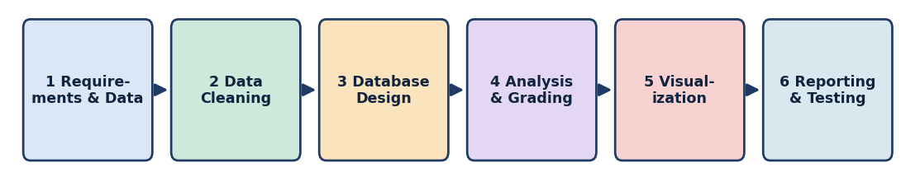
Fig. 1.1 – Phases of the project development life cycle

1.5 Problem Statement
In many departments the details of a student are kept in more than one place. The personal details are in one register, the attendance is in another, and the internal and university marks are in separate spreadsheets that are prepared by different faculty members. When the same student is entered twice, when a department name is typed in different ways or when a mark is left blank, the numbers that are reported to the management become unreliable.
A second difficulty is the time at which problems are noticed. Total marks, averages, ranks and arrear counts are usually calculated by hand at the end of the semester, so the students who are falling behind are found only after the results are published. The department therefore needs a small, reliable system that keeps the data in one place, cleans it, calculates every performance measure automatically and points out the students who need help while there is still time to act.

1.6 Scope of the Project
The project was carried out on a sample data set of second-year students and is limited to the following scope.
    - Included: collection and cleaning of student, attendance and marks data for three departments and six subjects;
    - Included: a normalised SQLite database with add, search, update and delete operations for student records;
    - Included: calculation of total, average, grade, rank and arrears, with subject-wise and department-wise analysis;
    - Included: charts, correlation study, at-risk student list, dashboard and Excel report;
    - Not included: a web or mobile interface, real-time data entry by faculty, and connection to the live college database, which are suggested as future work in Chapter 6.

1.7 Organisation of the Report
The report is organised into six chapters. Each chapter builds on the one before it, so that the reader can move from the reason for the project to its design, its execution and finally its results.
    - Chapter 1 – Introduction: states the purpose of the project, the problem, the objectives, the scope and the modules.
    - Chapter 2 – Literature Review: explains the concepts of data cleaning, relational databases, visualization and academic analytics, and lists the tools.
    - Chapter 3 – Methodology: describes the approach, the data set, the database design, the grading scheme, the system requirements and the workflow.
    - Chapter 4 – Implementation: presents the five modules with code, output screenshots, test cases and the difficulties faced.
    - Chapter 5 – Results and Discussion: discusses the numerical results, the charts and the comparison with the manual method.
    - Chapter 6 – Conclusion and Future Work: summarises the work, the skills gained, the limitations and the scope for future improvement.

CHAPTER 2
LITERATURE REVIEW
This chapter gives the background of the concepts, techniques and tools used in the project.

2.1 Data Analytics and Data Cleaning
Data analytics is the process of examining data to discover patterns, draw conclusions and support decisions. A typical workflow has four stages: collecting the data, preparing it, analysing it and communicating the results. Data preparation is the most time-consuming stage, because real-world data almost always contains duplicate records, missing values, inconsistent spellings and wrong data types. Analysis carried out on such data leads to misleading results, which is why cleaning is treated as an essential step and not as an optional one.
In Python, the pandas library provides ready-made methods for this stage – for example drop_duplicates() to remove repeated rows, isnull() to detect missing values, fillna() to replace them and str.strip() and str.upper() to standardise text. Missing numeric values can be replaced by the mean or the median; the median is preferred when values are skewed or contain outliers, because it is not pulled by extreme values.

2.2 Relational Databases and SQL
A relational database stores data in tables made of rows and columns. Each table has a primary key that identifies every row uniquely, and tables are connected through foreign keys. Splitting the data into related tables (normalisation) avoids repetition – a subject name, for example, is stored once in a subjects table instead of being repeated in every mark record – and it protects data integrity through constraints.
Structured Query Language (SQL) is the standard language for working with relational data. Statements such as SELECT, JOIN, GROUP BY and ORDER BY allow large data sets to be summarised with a single query. SQLite was chosen for this project because it is a lightweight, serverless database that stores everything in one file and is included with Python.

2.3 Data Visualization and Dashboards
Charts convert numbers into a form that people understand quickly. Bar charts compare categories, pie and donut charts show proportions, box plots show the spread of values, scatter plots reveal relationships between two variables and heatmaps display correlation between many variables at once. A dashboard combines the most important charts and key figures on one screen so that a decision maker can see the overall picture at a glance. The matplotlib library was used to create all charts in this project.

2.4 Academic Performance Analytics
Academic analytics uses student data to understand and improve learning outcomes. Commonly used measures are the average mark, the pass percentage, the grade distribution and the number of arrears. Studies in this area repeatedly report a positive relationship between class attendance and examination performance, which is measured with the Pearson correlation coefficient (r). A value of r close to +1 indicates a strong positive relationship, while a value close to 0 indicates none. Early identification of students with low attendance or failed subjects allows counselling before the final examination.

2.5 Tools and Their Purpose
Table 2.1 – Tools and technologies used
Tool / Library | Purpose in the project
Python 3 | Main programming language for cleaning, analysis and automation
pandas | Loading CSV files, cleaning data, grouping, pivot tables and statistics
NumPy | Numerical calculations, trend line fitting and random data generation
SQLite | Relational database that stores students, subjects and marks
SQL | Queries, joins and aggregation over the database tables
matplotlib | Bar, pie, box, scatter and heatmap charts and the dashboard
Jupyter Notebook | Interactive environment used to run and document the analysis
Microsoft Excel | Exporting the final performance report for the department

2.6 Existing Approaches and Their Limitations
Most colleges still manage student performance with one of three approaches. The first is the paper register, in which marks and attendance are written by hand and totalled with a calculator. The second is a set of separate Excel files, one for each class or each subject. The third is a ready-made college management software, which stores the data well but is often expensive and gives only fixed reports.
Each of these approaches has limits for a department that wants to understand its own results. Paper registers cannot be searched or analysed. Separate spreadsheets allow duplicates and inconsistent labels to enter the data without any warning, because nothing stops the same register number from being typed twice. Fixed reports of management software answer the standard questions but cannot easily answer new ones, such as whether attendance and marks are related in a particular class.
    - Scattered data: the data is scattered, so a complete picture of one student needs several files to be opened;
    - No validation: nothing prevents duplicate records, missing values or different spellings of the same department;
    - Late detection: results are calculated only at the end of the semester, so weak students are found late;
    - Slow analysis: searching, ranking and comparing departments take a long time when they are done by hand.

2.7 Need for the Proposed System
The Student Management & Performance Analytics System was planned to remove these limits with tools that are free and widely used. Python and pandas clean the data in a repeatable way, SQLite stores it with rules that prevent duplicate and orphan records, SQL and pandas produce the performance measures in a few seconds, and matplotlib and Excel present the results in a form that the department can read and share. Because the whole workflow is written as scripts, it can be run again on a new data set without repeating any manual work.

2.8 Statistical Measures Used
Several simple statistical measures are used in the analysis, and their meaning is given here so that the results in Chapter 5 can be read correctly.
    - Mean: the sum of the values divided by their number. The class average of 71.73 marks is a mean.
    - Median: the middle value when the data is arranged in order. It is used to fill missing values because it is not affected by very high or very low marks.
    - Standard deviation: a measure of how far the values are spread around the mean. A larger value means that the marks of the students differ more from one another.
    - Pass percentage: the percentage of records in which the total mark is 50 or above.
    - Pearson correlation coefficient (r): a number between -1 and +1 that shows how strongly two variables move together. It is calculated as the covariance of the two variables divided by the product of their standard deviations.
For the correlation study, the two variables are the attendance percentage and the average mark of each student. A value of r above 0.5 is generally read as a moderate to strong positive relationship, which means that students with higher attendance also tend to have higher marks. Correlation only shows that two things move together; it does not by itself prove that one causes the other, and this point is kept in mind when the findings are discussed.

CHAPTER 3
METHODOLOGY

3.1 Overall Approach
The project followed a step-by-step approach in which the output of each phase became the input of the next. The requirements and the structure of the data were understood first, the data was then cleaned, moved to a database, analysed, visualised and finally exported as a report. Every step was tested on the same data set so that the numbers reported in the results chapter can be traced back to the code.
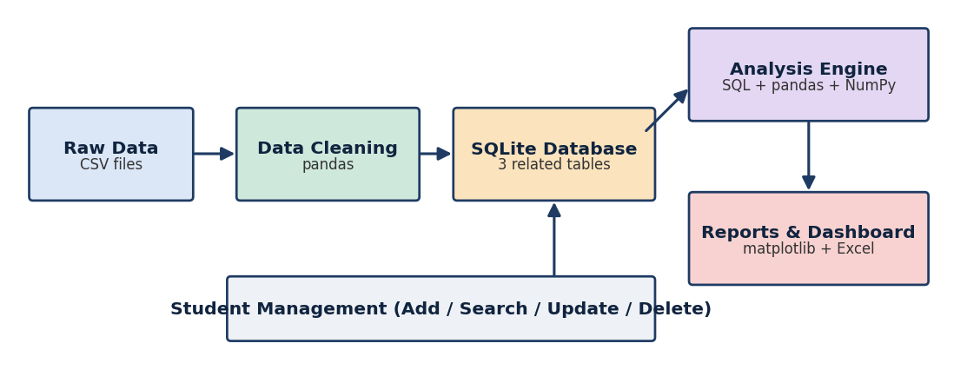
Fig. 3.1 – System architecture of the Student Management & Performance Analytics System

3.2 Data Set Description
A data set representing the second-year students of three departments – Artificial Intelligence & Data Science, Computer Science & Engineering and Information Technology – was prepared for the project. Since real student records are confidential, the names and marks used here are sample values generated with realistic patterns, but the structure of the files matches the records that a college maintains. The raw data was supplied in three CSV files:
    - raw_students.csv – 124 rows with register number, name, gender, department, year and attendance percentage.
    - raw_marks.csv – 720 rows with the internal (out of 40) and external (out of 60) marks of each student in six subjects.
    - subjects.csv – the six subject codes and names: Discrete Mathematics, Data Structures, Database Management Systems, Python for Data Science, Probability & Statistics and Machine Learning Basics.
The raw files deliberately contained the usual data quality problems – 4 duplicate student records, missing values in attendance and marks, and department names typed in different ways – so that the data cleaning module could be demonstrated on real-looking data.

3.3 Database Design
The database was designed with three tables in third normal form. The students table stores one row per student; the subjects table stores one row per subject; and the marks table connects the two, holding one row for each student–subject pair. The register number and the subject code form a composite primary key in the marks table, which makes it impossible to store two mark entries for the same subject of the same student.
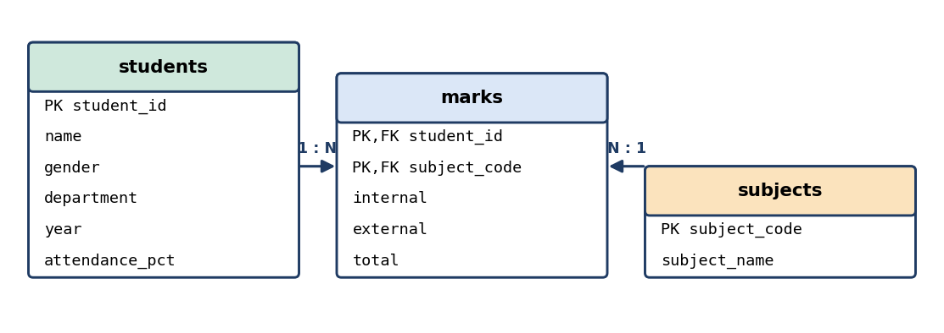
Fig. 3.2 – Entity Relationship (ER) diagram of the database

3.4 Evaluation and Grading Scheme
The total mark of a subject is the sum of the internal mark (out of 40) and the external mark (out of 60), giving a maximum of 100. A student clears a subject when the total is 50 or above; a total below 50 is counted as an arrear. The overall average of the six subjects decides the grade, as shown below. A student is called “at risk” when the attendance is below 75 % or when at least one arrear is present.
Table 3.1 – Grade scale used for the average marks
Average marks | Grade | Meaning
90 and above | O | Outstanding
80 – 89 | A+ | Excellent
70 – 79 | A | Very good
60 – 69 | B+ | Good
50 – 59 | B | Average
Below 50 | RA | Re-appearance

3.5 Analysis Methods
    - Descriptive statistics: mean, median, minimum, maximum and standard deviation of marks and attendance.
    - Grouped analysis: subject-wise and department-wise average and pass percentage using GROUP BY and pandas groupby().
    - Ranking: students are ranked in descending order of their average marks.
    - Correlation: Pearson correlation coefficient between attendance and average marks, and between the subjects.
    - Risk identification: rule-based filtering of students with low attendance or arrears.

3.6 System Requirements
The system does not need special equipment. Table 3.2 lists the minimum hardware and the software that are needed to run the scripts and the notebook.
Table 3.2 – Minimum hardware and software requirements
Item | Requirement
Processor | Intel Core i3 or equivalent, or higher
Memory (RAM) | 4 GB minimum (8 GB recommended for smooth notebook use)
Storage | About 1 GB of free disk space
Operating system | Windows 10 / 11, Linux or macOS
Programming language | Python 3
Libraries | pandas, NumPy, matplotlib, sqlite3 (built into Python)
Environment | Jupyter Notebook and VS Code
Other software | Microsoft Excel to open the exported performance report

3.7 Functional and Non-Functional Requirements
The requirements of the system were written down before the coding started, so that every module could be checked against them at the end.
Functional requirements
    - The system shall load the student, marks and subject files and report the number of records and missing values.
    - The system shall remove duplicate records and standardise the department names.
    - The system shall store the cleaned data in a relational database with primary and foreign keys.
    - The user shall be able to add, search, update and delete a student record.
    - The system shall calculate the total, average, grade, rank and number of arrears of every student.
    - The system shall produce charts, an at-risk student list, a dashboard and an Excel report.
Non-functional requirements
    - Accuracy and repeatability: the results must be the same every time the scripts are run on the same data.
    - Data integrity: the database must reject a duplicate register number and must not keep marks of a deleted student.
    - Performance: the analysis of 120 students and 720 mark records must finish within a few seconds on an ordinary computer.
    - Maintainability: the code is divided into separate files for data preparation, the pipeline, management functions and charts, so that any part can be changed without disturbing the others.

3.8 Data Processing Workflow
The path that the data follows from the raw files to the final report is described in the following steps.
    - Step 1 – Load: The three raw CSV files are read into pandas data frames and inspected with head(), shape and isnull().
    - Step 2 – Clean: Duplicates are dropped, department names are standardised and missing values are filled with medians.
    - Step 3 – Derive: The internal and external marks are added to give the total mark of each subject.
    - Step 4 – Store: The cleaned tables are written into the SQLite database student_system.db.
    - Step 5 – Analyse: SQL queries and pandas group-by operations produce the totals, averages, grades, ranks and arrears.
    - Step 6 – Present: matplotlib creates the charts and the dashboard, and the result tables are exported to Excel.
Because the output of every step is saved before the next step begins, an error can be traced to the step in which it occurred, and only that step needs to be repeated after it is corrected.

CHAPTER 4
IMPLEMENTATION
This chapter describes the practical execution of each module, including the code and the output screenshots taken from the development environment.

4.1 Module 1: Project Setup and Data Collection
Services used: Python 3, pandas, NumPy, Jupyter Notebook, VS Code
A project folder was created with separate places for the data files, the scripts and the reports. The scripts were written in a modular way – generate_data.py prepares the raw files, pipeline.py performs cleaning, database loading and analysis, crud.py holds the student management functions and figs.py creates the charts.
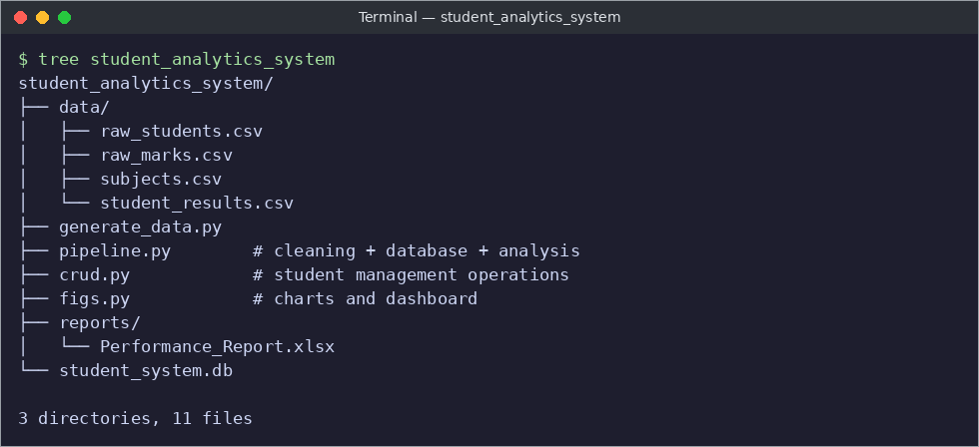
Fig. 4.1 – Project folder structure
The raw CSV files were loaded into pandas data frames and inspected with head() and shape to understand the columns and the number of records.
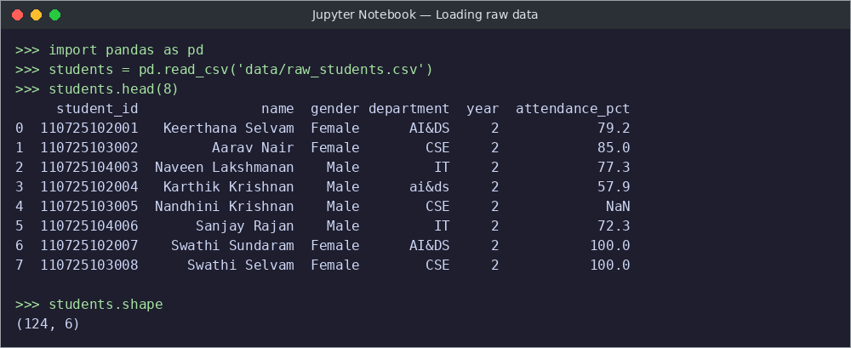
Fig. 4.2 – Loading and previewing the raw student data

4.2 Module 2: Data Cleaning
Services used: pandas, NumPy
Before cleaning, the quality of the data was checked. The check showed 6 missing attendance values, 4 missing internal marks, 9 missing external marks, 4 duplicate student rows and seven different spellings of the three department names (for example “cse ”, “Cse”, “It ” and “ai&ds”).
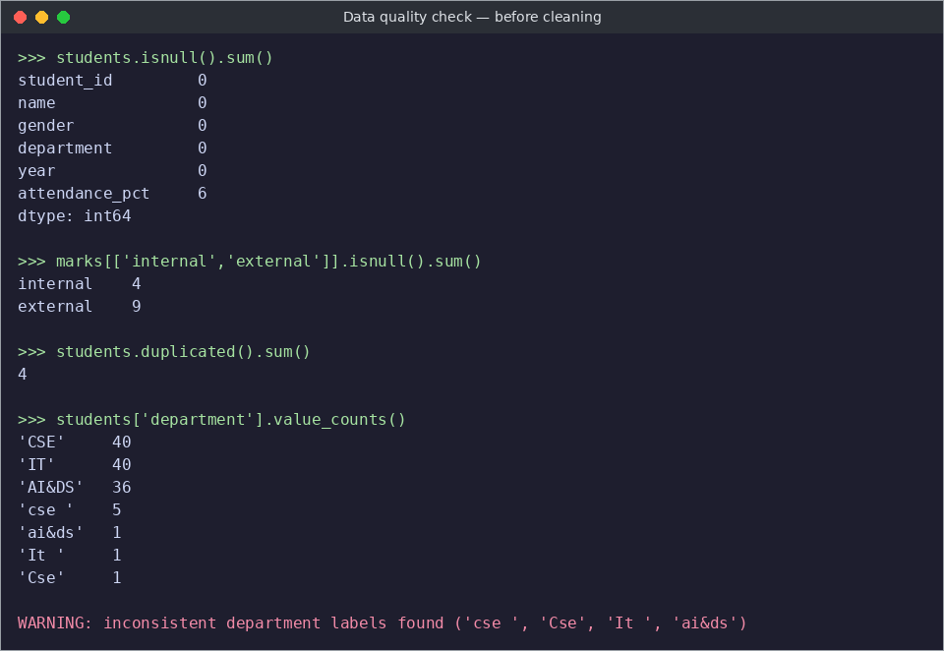
Fig. 4.3 – Data quality check before cleaning
Cleaning steps
    - Duplicate rows were removed using drop_duplicates(), which reduced the students from 124 to 120.
    - Department names were standardised with str.strip() and str.upper(), leaving exactly three categories – AI&DS, CSE and IT.
    - Missing attendance values were filled with the median attendance of the same department.
    - Missing internal and external marks were filled with the median mark of the same subject.
    - The total mark of every subject was calculated as internal + external.
stu = stu.drop_duplicates()
stu["department"] = stu.department.str.strip().str.upper()
stu["attendance_pct"] = stu.groupby("department")["attendance_pct"] \
.transform(lambda s: s.fillna(s.median()))
for col in ["internal", "external"]:
mk[col] = mk.groupby("subject_code")[col] \
.transform(lambda s: s.fillna(s.median()))
mk["total"] = (mk.internal + mk.external).astype(int)
Code 4.1 – Data cleaning with pandas
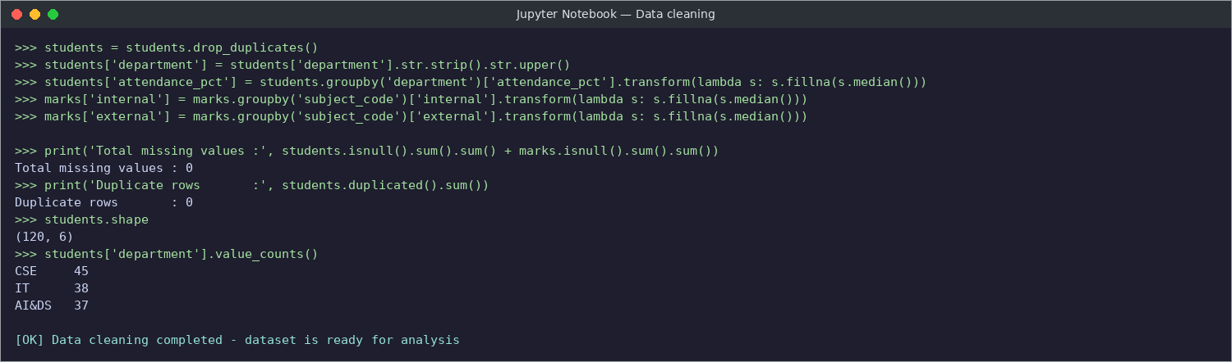
Fig. 4.4 – Data cleaning output: no missing values, no duplicates

4.3 Module 3: Database and Student Management
Services used: SQLite, SQL, Python sqlite3 module
The cleaned data was loaded into a SQLite database named student_system.db. The three tables were created with primary keys, foreign keys and NOT NULL constraints exactly as shown in the ER diagram, and were then filled from the data frames.
CREATE TABLE students(student_id TEXT PRIMARY KEY, name TEXT NOT NULL,
gender TEXT, department TEXT, year INTEGER, attendance_pct REAL);
CREATE TABLE subjects(subject_code TEXT PRIMARY KEY, subject_name TEXT NOT NULL);
CREATE TABLE marks(student_id TEXT, subject_code TEXT, internal INTEGER,
external INTEGER, total INTEGER, PRIMARY KEY(student_id, subject_code),
FOREIGN KEY(student_id) REFERENCES students(student_id),
FOREIGN KEY(subject_code) REFERENCES subjects(subject_code));
Code 4.2 – Table creation in SQLite
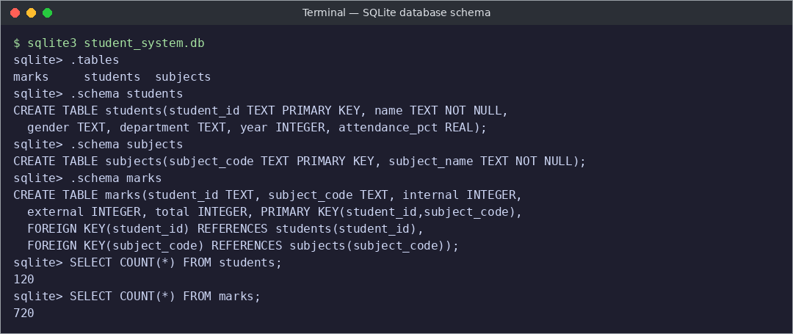
Fig. 4.5 – Database tables and schema in SQLite
Student management operations
A separate module, crud.py, provides four functions – add_student(), search_student(), update_attendance() and delete_student(). The add function inserts a new record, the search function finds students by a part of the name or register number, the update function changes the attendance and the delete function removes the student together with his or her marks. Error handling returns a clear message when the student is not found, and the primary key constraint rejects a duplicate register number.
def search_student(keyword):
with conn() as c:
return c.execute(
"SELECT student_id, name, department, attendance_pct FROM students "
"WHERE name LIKE ? OR student_id LIKE ?",
(f"%{keyword}%",) * 2).fetchall()

def delete_student(sid):
with conn() as c:
c.execute("DELETE FROM marks WHERE student_id=?", (sid,))
n = c.execute("DELETE FROM students WHERE student_id=?", (sid,)).rowcount
return "[OK] Student deleted" if n else "[ERROR] Student not found"
Code 4.3 – Search and delete functions
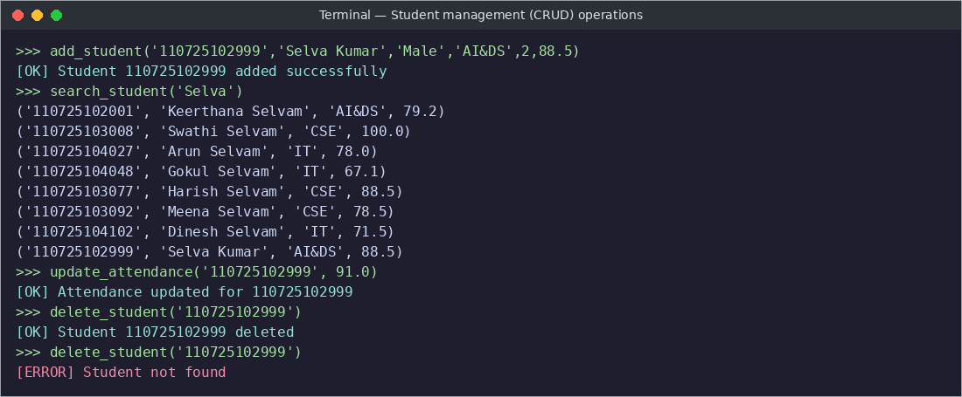
Fig. 4.6 – Testing the add, search, update and delete operations
A SQL join between the students and marks tables was used to find the top students by average mark:
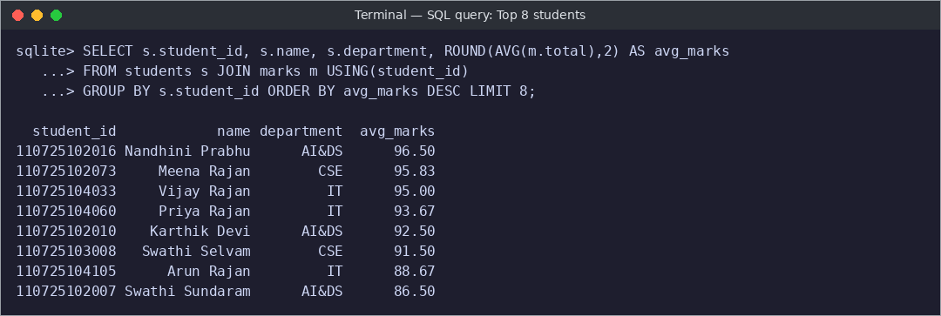
Fig. 4.7 – SQL query listing the top eight students

4.4 Module 4: Performance Analysis
Services used: pandas, NumPy, SQL
The marks of all subjects were joined with the student details and converted into one row per student with pivot_table(). For every student the total, the average, the number of arrears, the grade and the rank were calculated.
piv = df.pivot_table(index=["student_id","name","department","attendance_pct"],
columns="subject_code", values="total").reset_index()
piv["total"] = piv[codes].sum(axis=1)
piv["average"] = (piv.total / len(codes)).round(2)
piv["arrears"] = (piv[codes] < 50).sum(axis=1)
piv["grade"] = piv.average.apply(grade)
piv["rank"] = piv.average.rank(ascending=False, method="min").astype(int)
Code 4.4 – Calculating average, arrears, grade and rank
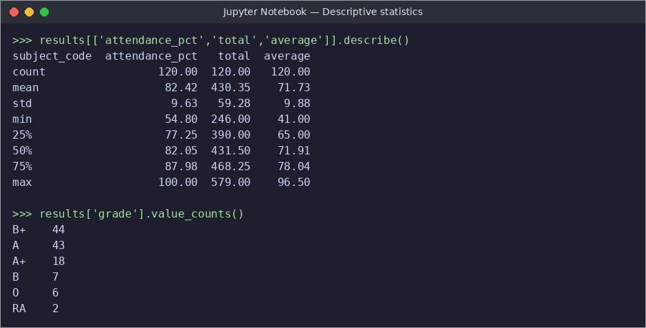
Fig. 4.8 – Descriptive statistics and grade counts

4.5 Module 5: Visualization and Reporting
Services used: matplotlib, Excel
Subject-wise performance
The average marks of each subject were compared with a bar chart. Python for Data Science has the highest average, while Discrete Mathematics has the lowest.
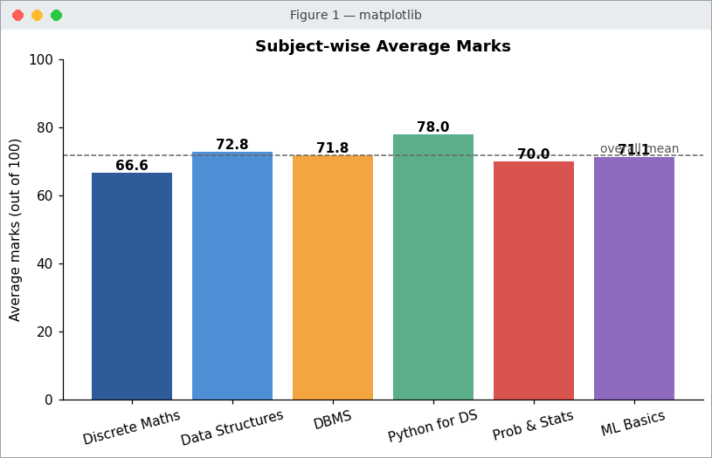
Fig. 4.9 – Subject-wise average marks
Grade distribution and result status
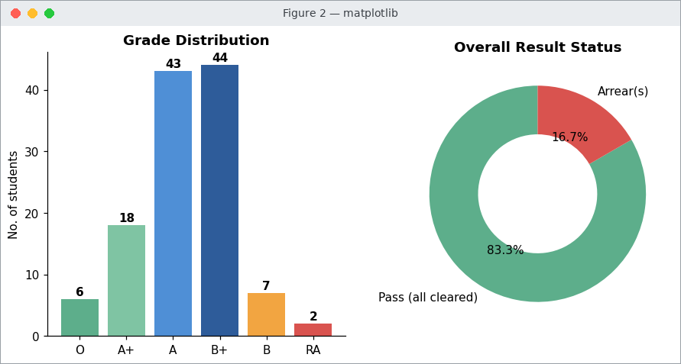
Fig. 4.10 – Grade distribution and overall pass / arrear status
Attendance versus performance
A scatter plot with a fitted trend line was drawn to study whether students who attend more classes score higher marks. The trend line clearly rises with attendance.
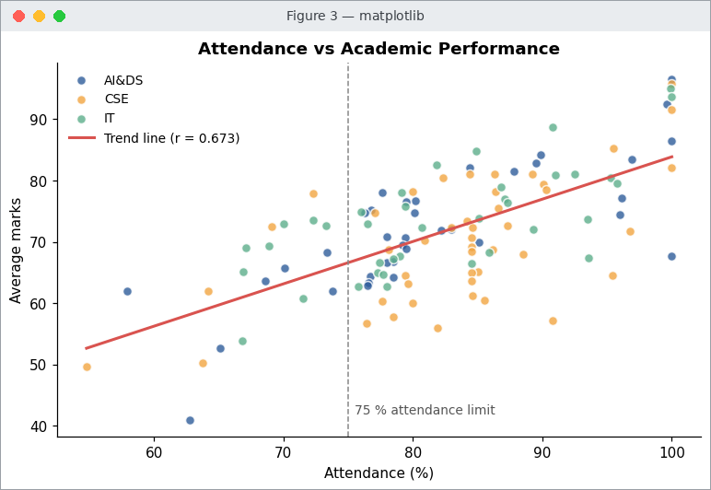
Fig. 4.11 – Relationship between attendance and average marks
Department comparison and score spread
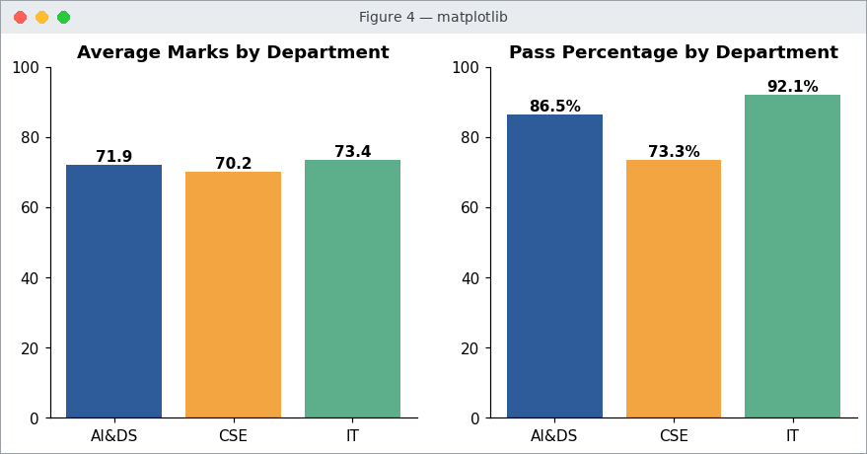
Fig. 4.12 – Average marks and pass percentage of each department
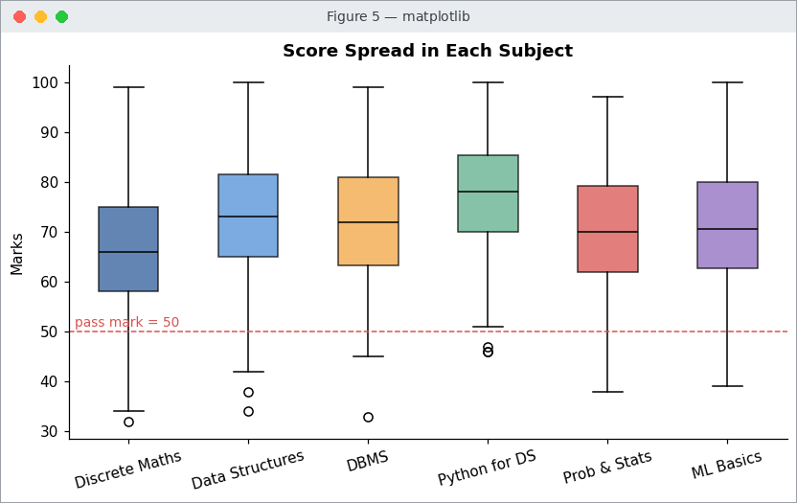
Fig. 4.13 – Box plot showing the spread of marks in each subject
Correlation heatmap
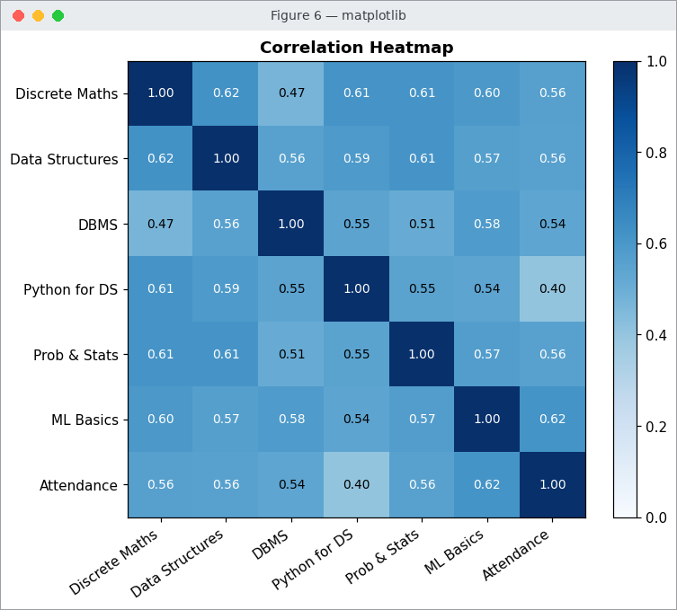
Fig. 4.14 – Correlation between subjects and attendance
Identification of at-risk students
Students with attendance below 75 % or with at least one arrear were filtered automatically and sorted by the number of arrears, so that the counsellors can contact the most critical students first.
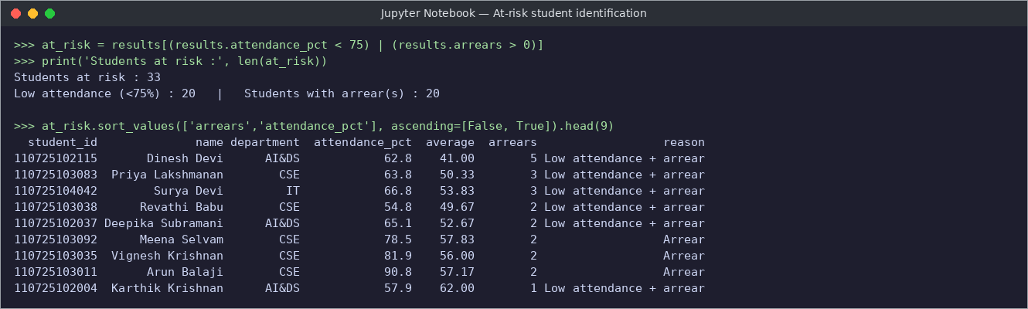
Fig. 4.15 – List of at-risk students

Analytics dashboard and Excel report
Finally, the key figures and the main charts were combined into a single dashboard. The complete result table was also exported to an Excel workbook with two sheets – Student Results and At-Risk Students – which can be handed over to the department.
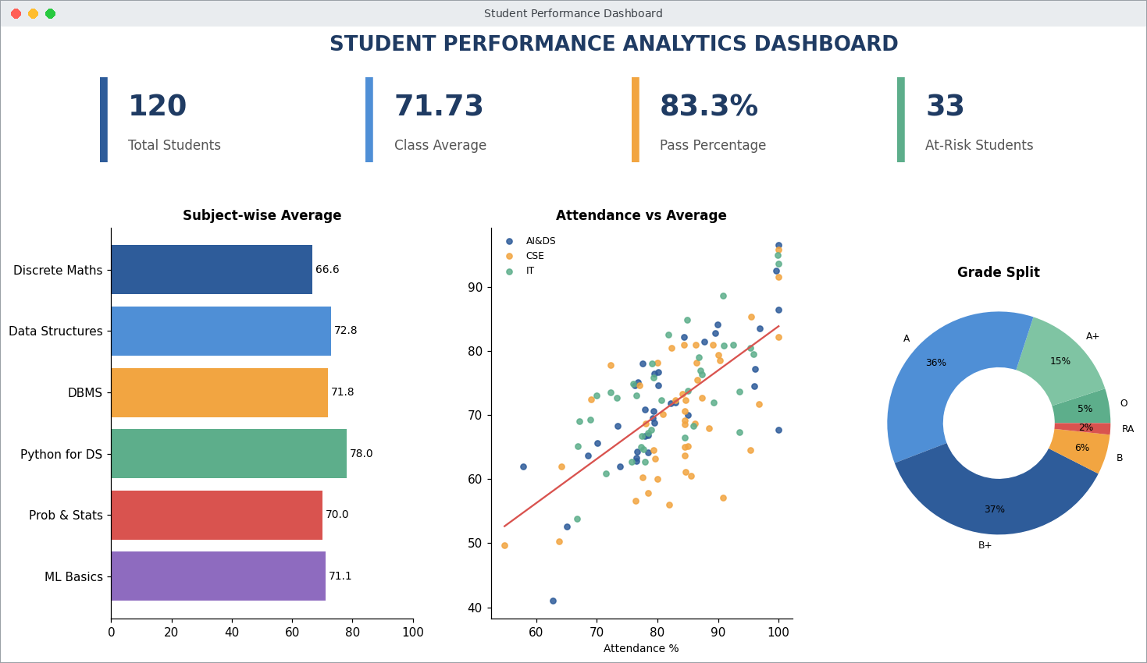
Fig. 4.16 – Student Performance Analytics Dashboard
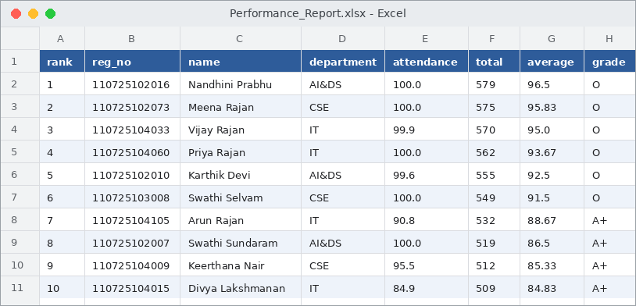
Fig. 4.17 – Performance report exported to Excel

4.6 SQL Queries Used for Analysis
The analysis of Module 4 relies on a few SQL queries of the following form. The first query joins the students and marks tables and lists the students with the highest average marks. The second query groups the marks by subject to give the average and the pass percentage of each subject. The department-wise figures are obtained in the same way, by grouping on the department column.
SELECT s.student_id, s.name, s.department,
ROUND(AVG(m.total), 2) AS average
FROM students s JOIN marks m ON s.student_id = m.student_id
GROUP BY s.student_id
ORDER BY average DESC LIMIT 8;
Code 4.5 – Query for the top eight students
SELECT sb.subject_name, ROUND(AVG(m.total), 2) AS avg_marks,
ROUND(100.0 * SUM(m.total >= 50) / COUNT(*), 1) AS pass_pct
FROM marks m JOIN subjects sb ON m.subject_code = sb.subject_code
GROUP BY sb.subject_name;
Code 4.6 – Query for subject-wise average and pass percentage
A pass is counted when the total mark of a subject is 50 or above, which is the same rule that is used for the arrear count. The join between the tables is possible only because of the foreign keys, which is one of the benefits of storing the data in a relational database instead of a single spreadsheet.

4.7 Grade and Risk Logic
The grade of a student is decided from the average mark with the scale given in Table 3.1, and a student is marked at risk when the attendance is below 75 % or at least one arrear is present. Both rules are written as short functions so that the limits can be changed in one place if the college changes its policy.
def grade(avg):
if avg >= 90: return "O"
if avg >= 80: return "A+"
if avg >= 70: return "A"
if avg >= 60: return "B+"
if avg >= 50: return "B"
return "RA"

risk = piv[(piv.attendance_pct < 75) | (piv.arrears > 0)]
risk = risk.sort_values("arrears", ascending=False)
Code 4.7 – Grade function and at-risk filter

4.8 Testing of the System
Every module was tested with sample inputs before the next module was started. The test cases in Table 4.1 cover the student management functions, the data cleaning and the calculation of grades. In each case the observed result matched the expected result.
Table 4.1 – Test cases and results
No. | Test case | Expected result | Status
1 | Add a student with a new register number | Record is inserted and an OK message is shown | Passed
2 | Add a student with an existing register number | Record is rejected by the primary key | Passed
3 | Search by a part of the name | All students with matching names are listed | Passed
4 | Search by register number | The matching student is listed | Passed
5 | Update the attendance of a student | New attendance value is stored | Passed
6 | Delete an existing student | Student and marks are removed | Passed
7 | Delete a student who does not exist | Error message: student not found | Passed
8 | Run the cleaning module | No duplicates and no missing values remain | Passed
9 | Average mark of 96.5 | Grade O is assigned | Passed

4.9 Challenges Faced and Solutions
Some difficulties were met during the internship. They are listed in Table 4.2 together with the way in which each one was solved.
Table 4.2 – Challenges and solutions
Challenge | Solution
Seven different spellings of three departments | Text was trimmed and converted to upper case with str.strip() and str.upper()
Missing attendance and marks | Values were filled with the department-wise or subject-wise median
Repeated student records | drop_duplicates() reduced the students from 124 to 120
Two mark entries for the same subject of one student | A composite primary key on student and subject was defined
Marks left behind after a student is deleted | The delete function removes the marks first and then the student
Too many separate charts to read | The key figures and charts were combined into one dashboard

CHAPTER 5
RESULTS AND DISCUSSION

5.1 Data Cleaning Results
Table 5.1 – Data quality before and after cleaning
Quality issue | Before cleaning | After cleaning
Student records | 124 | 120
Duplicate rows | 4 | 0
Missing attendance values | 6 | 0
Missing internal marks | 4 | 0
Missing external marks | 9 | 0
Department label variants | 7 | 3

Cleaning removed all duplicates and missing values, and reduced the seven spellings of the department names to the three valid categories. All 120 remaining students have a complete set of six subject marks, giving 720 mark records in the database.

5.2 Overall Performance
The class of 120 students obtained an average of 71.73 marks. 83.3 % of the students cleared all six subjects, while 20 students have at least one arrear. The largest group of students falls in the B+ grade (44 students), followed by A (43), A+ (18) and B (7); 6 students achieved the O grade and 2 students received RA. The top scorer was Nandhini Prabhu of AI&DS with an average of 96.5.

5.3 Subject-wise Analysis
Table 5.2 – Subject-wise average marks and pass percentage
Code | Subject | Average marks | Pass %
MA3301 | Discrete Mathematics | 66.62 | 92.5
CS3302 | Data Structures | 72.84 | 95.8
AD3303 | Database Management Systems | 71.78 | 95.8
AD3304 | Python for Data Science | 78.03 | 97.5
AD3305 | Probability & Statistics | 69.95 | 95.0
AD3306 | Machine Learning Basics | 71.14 | 95.8

Python for Data Science recorded the highest average (78.03) and the highest pass percentage, showing that the practical, programming-oriented subject is the easiest for the students. Discrete Mathematics has the lowest average (66.62) and the lowest pass percentage (92.5 %); the box plot also shows the widest spread and the most low scores in this subject, so extra tutorials for Discrete Mathematics are recommended.

5.4 Department-wise Analysis
Table 5.3 – Department-wise results
Department | Students | Average marks | Pass %
AI&DS | 37 | 71.94 | 86.5
CSE | 45 | 70.15 | 73.3
IT | 38 | 73.38 | 92.1

IT has the highest average (73.38) and pass percentage (92.1 %), followed by AI&DS (71.94; 86.5 %). CSE has the lowest average (70.15) and the lowest pass percentage (73.3 %). The difference between the departments is small in terms of average marks but noticeable in the pass percentage, which means the CSE department has more students with one or two arrears.

5.5 Attendance and Performance
Table 5.4 – Average marks by attendance range
Attendance range | No. of students | Average marks
Below 75 % | 20 | 63.25
75 % to 89.9 % | 75 | 70.90
90 % and above | 25 | 80.98

The correlation coefficient between attendance and average marks is r = 0.673, which indicates a moderately strong positive relationship. Students with 90 % attendance or more score 81.0 marks on average, whereas students below 75 % score only 63.2, a difference of about 18 marks. The heatmap also shows that the marks of the different subjects are positively correlated, meaning that a student who is strong in one subject is generally strong in the others.

5.6 At-Risk Students
The rule-based filter identified 33 at-risk students (27.5 % of the class): 20 students have attendance below 75 % and 20 students have arrears; some students belong to both groups. Because this list is produced automatically from the database, it can be regenerated after every internal test, which allows the faculty to counsel students during the semester instead of after the results.

5.7 Key Findings and Recommendations
    - Attendance is the strongest single factor linked with marks, so attendance monitoring should be part of the regular review.
    - Discrete Mathematics needs additional support because of its low average and pass percentage.
    - Data cleaning is necessary before analysis – without it the department counts and averages would have been wrong.
    - A central database replaces scattered spreadsheets and makes searching and updating quick.
    - The dashboard gives the department a one-page summary of class results.

5.8 Graphical Summary of the Results
Two further charts were prepared from the tables of this chapter so that the main results can be seen at a glance. Figure 5.1 compares the number of quality problems before and after cleaning. Every count of duplicate rows and missing values falls to zero, and the seven department spellings are reduced to the three valid names.
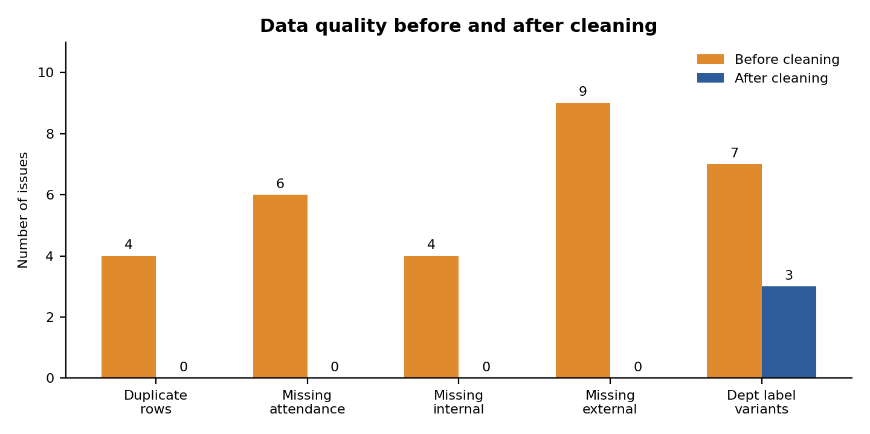
Fig. 5.1 – Data quality issues before and after cleaning
Figure 5.2 shows the average marks of the three attendance groups. The bars rise from 63.25 for students with attendance below 75 % to 80.98 for students with 90 % attendance or more, which is the same pattern as the trend line of Fig. 4.11.
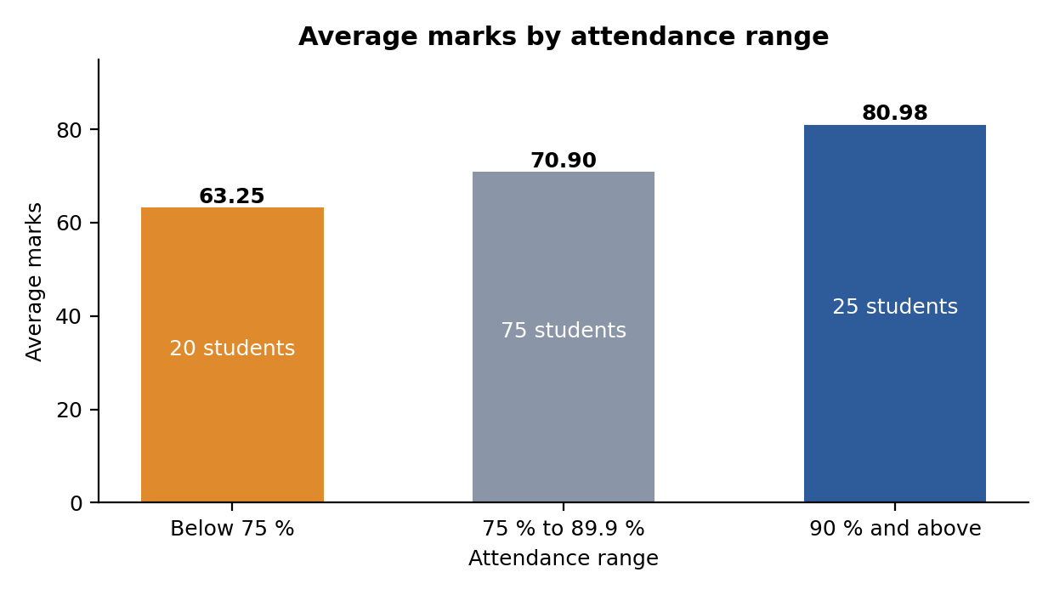
Fig. 5.2 – Average marks in each attendance range

5.9 Comparison with the Manual Method
Table 5.5 compares the way in which the common tasks of a department are done manually with the way in which they are done by the developed system.

 | manual method | Developed system
Finding a student | Turning pages of registers or searching several files | One search by name or register number
Checking duplicates | Noticed only by chance | Removed automatically during cleaning
Total, grade and rank | Calculated by hand for every student | Calculated for all students in one run
Finding weak students | After the results are published | Filtered at any time from the database
Reports and charts | Prepared separately with much effort | Dashboard and Excel report are generated automatically

Table 5.5 – Manual method compared with the developed system

5.10 Discussion
The results show that the quality of the data has a direct effect on the quality of the conclusions. Before cleaning, the student count was 124 instead of 120 and the departments appeared as seven groups, so the department-wise averages would have been wrong. After cleaning, every figure in this chapter can be traced back to the database and repeated with the same code.
The analysis also gives the department some practical points for action. The gap of about 18 marks between the highest and the lowest attendance group supports a regular attendance review. The low average of Discrete Mathematics suggests extra tutorials, and the lower pass percentage of the CSE department shows where counselling should begin. Since the data used here is a sample, the exact values will change with real records, but the method remains the same.

CHAPTER 6
CONCLUSION AND FUTURE WORK

6.1 Conclusion of Individual Modules
    - Data collection and cleaning: raw records with duplicates, missing values and inconsistent labels were converted into a clean data set of 120 students and 720 mark records.
    - Database and management: a normalised SQLite database with primary and foreign keys was built, and the add, search, update and delete operations work correctly, including error handling.
    - Performance analysis: total, average, grade, rank and arrear status were calculated for every student, along with subject-wise and department-wise statistics.
    - Visualization and reporting: charts, a correlation study, an at-risk list, a dashboard and an Excel report present the results in an easy-to-understand form.

6.2 Overall Conclusion
The internship gave practical experience of the complete data analytics workflow. The Student Management & Performance Analytics System shows how raw, unorganised student data can be cleaned, stored in a database, analysed and turned into information that supports decisions. The analysis confirmed that attendance strongly influences academic performance and helped to identify the weaker subject and the students who need support. Through this project the intern gained hands-on skills in Python, pandas, NumPy, SQL, SQLite, matplotlib and Excel, and also learned the importance of data quality, documentation and clear presentation of results.

6.3 Future Work
    - Develop a web interface using Flask or Streamlit so that faculty can use the system without writing code.
    - Add role-based login for students, faculty and the head of the department.
    - Build a machine learning model to predict the chance of an arrear from attendance and internal marks.
    - Add semester-wise history to compare the progress of every student over time.
    - Send automatic e-mail or SMS alerts to students and parents when attendance falls below the limit.
    - Connect the system to the real college database and generate dashboards with Power BI or Tableau.

6.4 Skills Acquired
During the internship the following technical and professional skills were gained.
    - Data handling: loading, cleaning, grouping and summarising data with pandas and NumPy.
    - Databases: designing a normalised database and writing SQL queries with joins and aggregation.
    - Visualization: choosing the right chart for each question and combining charts into a dashboard.
    - Professional practice: writing modular code, testing every module, and documenting the work in a report.

6.5 Limitations of the Present Work
    - The data set is a sample generated with realistic patterns and not the actual records of the college.
    - The system is used through Python scripts and a notebook, so a faculty member needs some technical help to run it.
    - Only one semester of data is analysed, so the progress of a student over time cannot yet be studied.
    - The at-risk rule uses only attendance and arrears; other factors such as internal test trends are not considered.

6.6 Benefits of the System
For the department, the system saves the time that is spent on manual calculation, keeps all student data in one reliable place and gives an early warning about students who need support. For the students, early counselling can prevent arrears and improve attendance. For the intern, the project was a complete example of how a data analytics task is carried out in an organisation, from raw files to a report that can be handed over.

REFERENCES

[1] W. McKinney, Python for Data Analysis: Data Wrangling with pandas, NumPy, and Jupyter, 3rd ed. Sebastopol, CA, USA: O’Reilly Media, 2022.

[2] pandas Development Team, “pandas Documentation,” [Online]. Available: https://pandas.pydata.org/docs/

[3] NumPy Developers, “NumPy User Guide,” [Online]. Available: https://numpy.org/doc/stable/user/

[4] Python Software Foundation, “Python 3 Documentation,” [Online]. Available: https://docs.python.org/3/

[5] SQLite Consortium, “SQLite Documentation,” [Online]. Available: https://www.sqlite.org/docs.html

[6] J. D. Ullman and J. Widom, A First Course in Database Systems, 3rd ed. Upper Saddle River, NJ, USA: Pearson, 2007.

[7] J. Han, M. Kamber, and J. Pei, Data Mining: Concepts and Techniques, 3rd ed. Waltham, MA, USA: Morgan Kaufmann, 2011.

[8] J. W. Tukey, Exploratory Data Analysis. Reading, MA, USA: Addison-Wesley, 1977.

[9] Matplotlib Development Team, “Matplotlib Documentation,” [Online]. Available: https://matplotlib.org/stable/contents.html

[10] Microsoft, “Microsoft Excel Documentation,” [Online]. Available: https://support.microsoft.com/excel

APPENDIX
INTERNSHIP COMPLETION CERTIFICATE
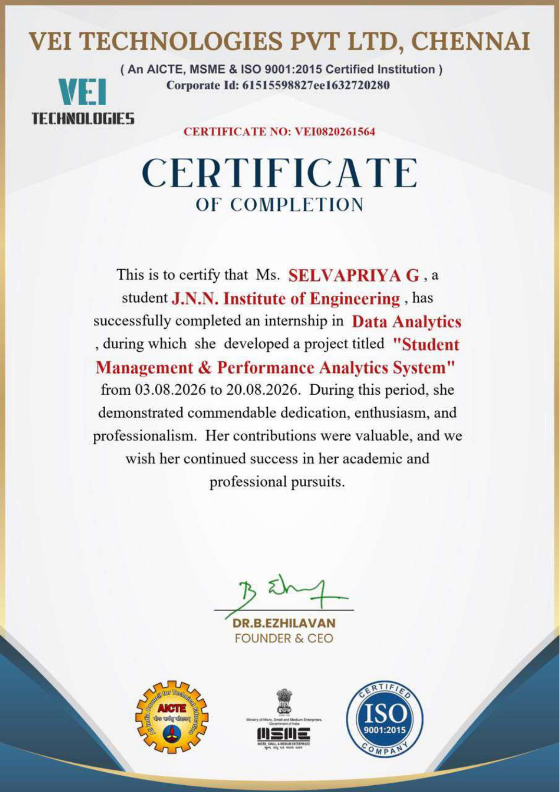
Certificate of Completion issued by VEI Technologies Pvt. Ltd., Chennai (Certificate No. VEI0820261564)

